Charlotte Ward
Project management plan

Contents
1. Project Aims 1
2. Project Scope 1
3. Project Deliverables 1
4. Project Cost 1
5. Resources Required 1
6. Project Schedule & Milestones 2
Pre-Project Phase 2
Research Phase 2
Report Phase 2
Reflection Phase 3
Gantt Chart 3
7. Communication Plan 3
8. Risk Management 3
9. Quality Guidelines 3

1. Project Aims
This project aims to identify whether or not a causal relationship between the usage of digital technologies, specifically social media, and the overall health and mental wellbeing of an individual exists. As well as this, the project aims to potentially identify differences between different social media sites, should the data facilitate a statistically significant observation. If a relationship can’t be established, the data may still be useful to present. This project also aims to produce a report and poster for a presentation being held online on the 5th of May.

2. Project Scope
This project focusses on the impacts of social media, without commenting on the overall impacts computers and devices can have on the lifestyle of an individual. Because of this, the project will not be asking general questions about time spent using devices, instead focussing on specific usage time and self-reported effects of certain platforms in particular.
As this project aims to examine the effects of social media, it’s important to clarify what platforms are considered to be social media, in this context. The social media platforms in question need to be designed around social networking, blogging or microblogging, personal messaging, and content-sharing, in a non-professional context. To that end, below are some social media platforms that do fit these criteria:
- Facebook
- Youtube
- WhatsApp
- Instagram
- Twitter
- Snapchat
- Tumblr
- Reddit
- Twitch
Some platforms that don’t fit these criteria are:
- LinkedIn
- Medium
- Crunchbase
- F6S

3. Project Deliverables
Depending on the specific nature of the data collected, this project aims to deliver various graphs that demonstrate the existence or non-existence of a correlation between various statistics and the self-reported information about health and wellbeing.
- A scatter plot showing a potential relationship between time spent on social media and self-reported wellbeing.
- Additional graphs showing any potential differences between different subgroups, including platform usage and groups based on time spent online.
- A written analysis of the self-reported descriptions of the impacts people have observed, along with an analysis of whether that lines up with the quantitative data, in the form of a report.
- A completed poster summarising the report, containing information about the survey, literature review, findings, and graphs demonstrating any potential correlations (or lack thereof) in the data.

4. Project Cost
As this project relies on self-reported information in the form of a questionnaire, having the funds to advertise the online questionnaire would greatly improve the quantity of the results. As well as this, a system other than Microsoft Forms would be preferable, with a centralised database for results, potentially involving costs for server hosting and software development. This being said, the scale of this project doesn’t require specialised hosting/software.

5. Resources Required
The questionnaire is the most resource-intensive part of this project, requiring assistance from individuals in order to get a large enough sample size. A few of the people I'm going to ask for help with sharing this are:
- Linda Ward, Marketing PHD and Prior Academic, with University Contacts
- Dan Purdy, Higher Education Tutor, with College Contacts
Additionally, this task involves the largest time requirement possible, in order to get enough results for the data to be statistically significant.

6. Project Schedule & Milestones
This Work Breakdown Structure (WBS) shows the key phases to the project, alongside the individual elements that makes up each phase. Each phase contains at least one child task, indicating a document or event that must be completed before the phase is over.
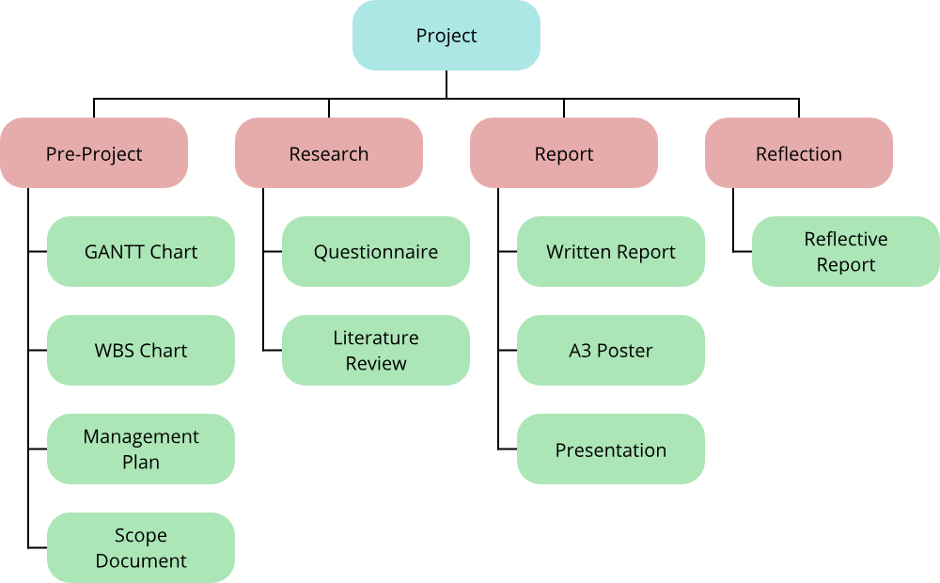

Pre-Project Phase
The Pre-Project phase involves the completion of this document, the project scope document, the Work Breakdown Structure, and the project Gantt Chart. This phase should be completed by the 22nd of April, allowing lots of time for the research phase to take place.

Research Phase
This phase involves the primary and secondary research involved in the project, comprised of a questionnaire and a literature review for both types of research respectively. The secondary research is supposed to support the primary research, aiding in the production of the questionnaire, alongside a review of existing literature. This phase is the longest phase, allowing lots of time for questionnaire responses to come back before the report phase. This phase should be completed by the 30th of April.

Report Phase
This phase involves the analysis of the data, with the A3 poster supplementing the overall report. This poster will be used in the presentation taking place on the fifth, meaning that the phase must be completed by the 5th of May (specifically before the presentation).

Reflection Phase
The reflective report has it's own phase due to being a large, low-priority document due to a distant deadline. This phase allows for me to focus entirely on the reflective report, ideally being completed by the 8th of May, but ultimately able to be delayed to the 19th of May.

Gantt Chart
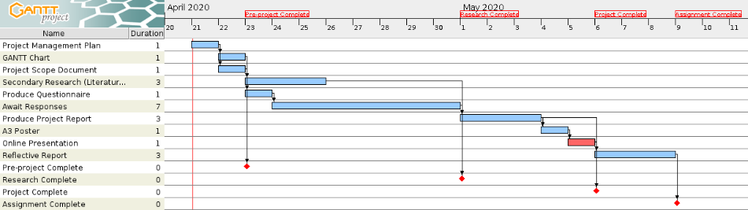
This Gantt chart shows the four milestones, each relating to the end of a phase.
- Pre-project Completed (by 22nd April)
- Research Completed (by 30th April)
- Project Completed (by 5th May)
- Assignment Completed (by 8th to 19th May)

7. Communication Plan
Dan Purdy and Linda Ward are both effectively shareholders in this project, with regular updates being a key part of this project. I can communicate with Linda verbally on a near-daily basis, aided by self-isolation. As well as this, I can communicate semi-regularly with Dan through Microsoft Teams with more subject-specific concerns and requests. I will be using these contacts to make sure that the project is kept to a high standard and to make sure that the milestones and deadlines can be met.

8. Risk Management
This risk management section will be updated daily should any further risks be identified before the completion of the project.
Risk | Effect | Solution
Low response quantity to the primary research. | Quantitative data would be far less accurate. | Focussing instead on qualitative results may mitigate this. As well as this, delaying the report and poster could help attract more results.
The report and poster might take longer to produce than assigned. | The presentation would be impossible without the poster. | Since the poster is required for the presentation, perhaps this should be a priority; the report can be finalised afterwards, potentially.

9. Quality Guidelines
The results of this project should comment on what kind of effect social media can have on the health and wellbeing of the users, as well as a potential analysis of the impacts. The data that could be used to comment on the effect could be:
- Differences between certain social media platforms and the impacts they have.
- An analysis of the impacts that time-spent can have.
- A commentary on whether or not time-spent has the largest effect, or whether the largest impact comes from another variable.
This data could be used to potentially encourage or discourage use of specific platforms or to recommend time-limiting device usage, which is particularly useful in the context of a college thanks to the common usage of social media among primarily younger individuals. Should the data not produce meaningful results, the information may still be useful in the context of the literature review or in a greater societal context, indicating the requirement for further research and understanding.

